Regression Analysis

Often data comes as a vector of related values. When we collect medical data, we might simultaneously collect from each patient his blood pressure, height, weight, temperature and the amount of cigarettes he smokes each day. Since each patient contributes all five of these values, he creates a vector of dimension (size) five which consists of these 5 numbers. These numbers are related to each other in that they describe one individual during a certain instant. When we collect economic data we may ask an individual about his income, the number of rooms in his home, the highest educational degree he received, the zip code where he lives and the value of his savings. Again, this information creates a vector of size 5, where all the data about each individual (at a certain instant) is recorded. The data in that vector is related in that it pertains to a specific individual.

Sometimes the various variables that are collected in the vector are themselves intrinsically related to one another (for example, height and weight) which often vary together (ie: tall people often weigh more then short people). Sometimes this relationship is a "cause and effect" relationship. For example, income may depend on where you live and how much schooling you have had.

In Regression Analysis we seek to explore and describe these cause and effect relationships. Does such a relationship between the variables really exist and, if so, what is the cause and effect relationship. In "simple linear regression" we assume that there is one explanatory variable (called the independent variable), usually denoted by X, and one explained variable (called the dependent variable), usually denoted by Y. Furthermore we assume that he relationship is linear (Y=a+bX). In "multiple linear regression" there is one dependent variable Y, and a series of K independent variable having the linear relationship 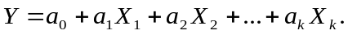 In multivariate regression there are m dependent variables and n independent variables (we won't even discuss this in our course). Non-linear regression refers to situations were we cannot make the assumption of linearity (again this will not be discussed). We will begin with an extensive discussion of simple linear regression but we should keep in mind that all the ideas developed will carry over to multiple regression.

Simple Linear Regression

In simple linear regression each data point collected is a pair of numbers (x,y). We will denote by 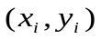the numbers for the i-th individual. We are interested in exploring the cause and effect relationship that X has on Y (we are said to be regressing X on Y). Thus X is the independent variable and Y is the dependent variable. We will assume that the form of the relationship is linear,
Y=a+bX.
The problem is that we do not know the values of a,b, all we possess are the n values and our assumption about the form of the relationship. Normally, this would not be a serious problem because we can take any 2 of the n data points and they would be sufficient to define the equation of a line ( the values of a,b).

The problem is that we will also assume that the linear relationship is not perfect and in each case there is an additional random error term. So that the equation for the i-th individual is
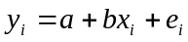
where 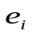 is the i-th random error term and where is distributed as a normal random variable with mean 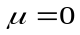 and variance 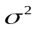 (which is the same for each ). Thus 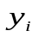 itself becomes a random variable distributed as
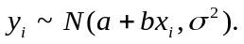
Again, our problem is to use the n data points to estimate a,b and . These estimates will be denoted a 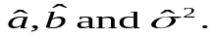

Now suppose that w have n points i=1,…,n and we plot these points on a graph as follows:

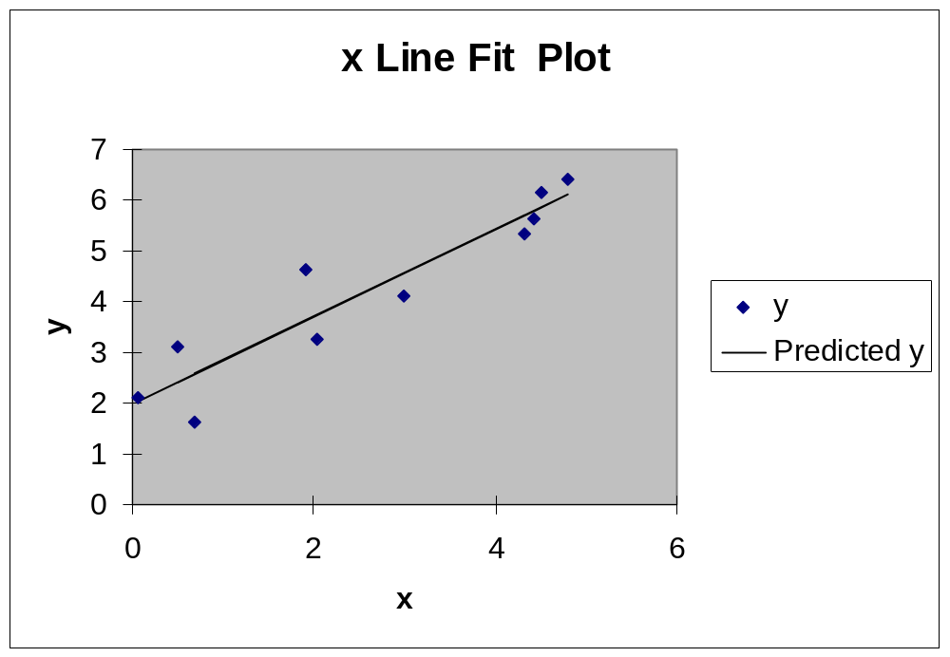

First notice that these points cannot all fall on any one line. This is because of the term. We have drawn a line through these points that seems to "fit these points the best". This is not the "true" regression line (relationship line), in the sense that this line is a function of random data. However, we could expect that if there were a really large number of data points then this line (what we will call the regression line) should be not very different from the true relationship line. Our problem is then to find the formula for the "line that fits the best". The values of a,b for that line will be the estimates 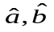 for the real line, and the quality of the fit will be used to calculate the estimate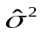. This line is called the "fitted regression line" or simply the "regression line".

Consider the following graph which show a regression line fitted to just a few points:

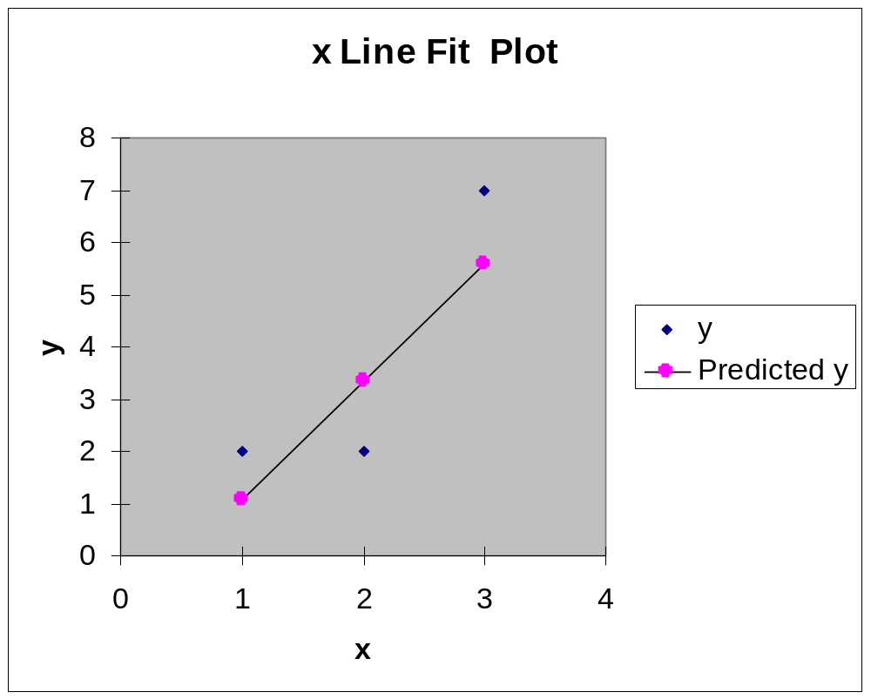

In this graph, we see the data points plotted as diamonds. We also see a plot of the regression line. On the regression line there are also circles plotted to indicate what the regression predicts the value of to be for each 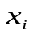. These values are called the "predicted " and are denoted as 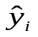. The difference between the values of and represents the error term 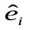 for the i-th individual and is called the i-th residual. Thus 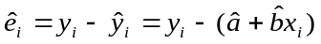. We will define the line that "fits the best" as the line that minimizes the sum of squares of the perceived error terms (the residuals). That is, the values of a,b that will minimize
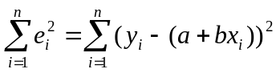.

To find the minimum of this "sums of squares" we will take the derivative once with respect to a and set the derivative equal to zero, and once with respect to b and set the derivative equal to zero. This will give us two equations and two unknowns which can be solved simultaneously for .

Now,
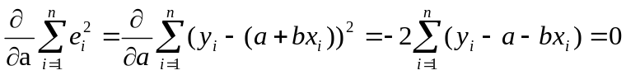
and
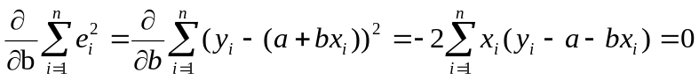.

These two equations can be written as
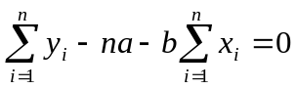
and
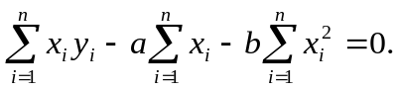
These two equations are called the normal equations. Solving simultaneously we get,

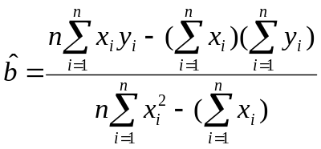
and
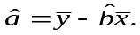

Example

The following x,y data lists the scores on a logic test and the incomes of 9 individuals. We are interested in seeing the cause and effect relationship of logic on income.

Logic score | 4 | 5 | 7 | 8 | 5 | 3 | 6 | 4 | 6
Income | 14 | 17 | 17 | 20 | 16 | 13 | 16 | 12 | 19

First we calculate:

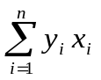 | 56 | 85 | 119 | 160 | 80 | 39 | 96 | 48 | 114
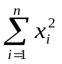 | 16 | 25 | 49 | 64 | 25 | 9 | 36 | 16 | 36
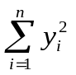 | 196 | 289 | 289 | 400 | 256 | 169 | 256 | 144 | 361

Then calculate

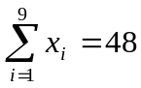 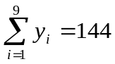 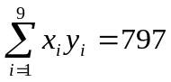 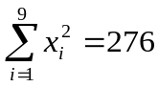 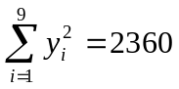 n=9

then

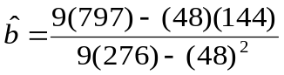 = 1.45
and
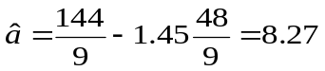.
The fitted regression line is
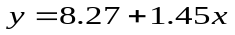.

Homework

1. A list of midterm and final exam grades for 9 students is given by the following table:
Midterm | 77 | 50 | 71 | 72 | 81 | 94 | 96 | 99 | 67
Final | 82 | 66 | 78 | 34 | 47 | 85 | 99 | 99 | 68

Calculate the fitted regression line to show the relationship about how the midterm grade predicts the final exam grade. For a student with an 80 on the midterm what would be the predicted final exam grade.

2. The winter heating bills for 10 randomly chosen apartments are examined to find the relationship between apartment size (square meters) and the total winter heating bills. The following is the data:

Apartment Size | 110 | 90 | 95 | 100 | 129 | 85 | 115 | 78 | 140 | 100
Heating Costs | 1500 | 1250 | 1200 | 1400 | 1800 | 1100 | 1500 | 1100 | 2000 | 1500

Find the appropriate fitted regression line that describes the relationship between apartment size and heating cost. What is the predicted value of the heating cost for a house of 120 meters.

Distribution of

It can be shown that under the assumption that 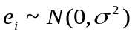 then
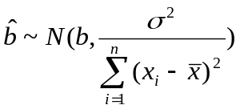
and
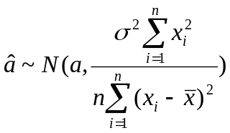.
(see appendix 1).

Partitioning the Sums of Squares

Notation
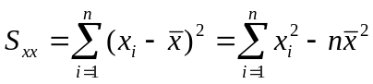
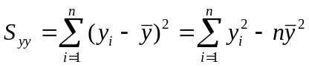
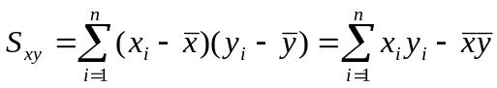.

Now after fitting the regression line the remaining minimized sum of squares of error is
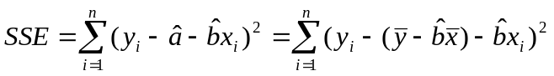
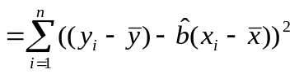
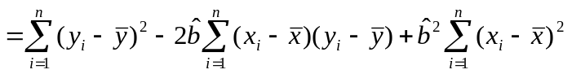
= 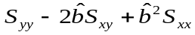.

Now realizing that

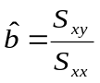
we get
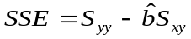.

Estimator of

An unbiased estimator of is given by
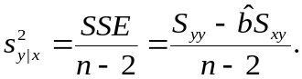

Example

For the data in our previous example involving income regressed on logic scores, we have
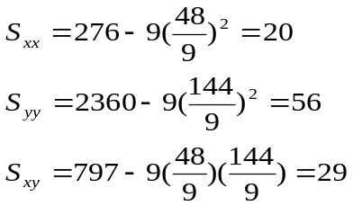
then
and
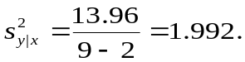

Now we have seen above that we can write . Now 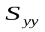 is the numerator of our old estimator of the variance (what we called till now the sample variance) and represents a measure of the total variability in the dependent variable y without taking the explanatory variable x into account. is often written as SST, which stands for total sum of squares. On the other hand SSE (which is the numerator of our current estimate of the variance) is an measure of the total variability of the variable y after taking into account the explanatory variable x. That is SSE is the remaining variability of y after we have adjusted y for the differing values of x.

The difference between and SSE must therefore represent the portion of the variability of y that was successfully explained by the differing values of x. This quantity is called SSR which stands for the sum of squares do to regression. From the formula above we have
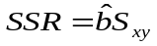.

Thus we have partitioned the sums of squares into
SST=SSE+SSR.

Example

In our example above involving the effects of logic on income, we have
SST=56
SSE=13.95
SSR=42.05

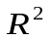

The value
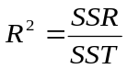
is a measure of the fraction of the total variability of the dependent y variable that is "explained" by the regression (by the independent x variable).

Example

In our case of the effect of logic on income, we have
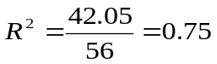
That is, 75% of the total variability in income (y) between the various people sampled is explained by the relationship between y and x. That 75% of all the differences in income among people is due to their different logic skills. Only 25% of the variability in income is left unexplained (apparently due to randomness).

The quantity is designated with a square sign because its square root was historically called the correlation coefficient (with the square root getting the same sign as 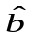). Thus in our case the correlation coefficient is 0.869.

An equivalent formula for the correlation coefficient is
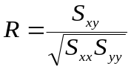.

Homework

For each of the 2 previous homework data sets, calculate
.

Confidence Intervals

Suppose that for some specific value of x (say 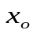) we are interested in predicting the resultant value 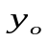. A point estimate for would be
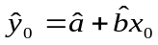.
While this is indeed an unbiased estimator for there is no indication about how close we really expect this value to be to . It makes sense to also calculate a 1-α% confidence interval for . To do this we need to differentiate between 2 cases. The first case is where is meant to be the value of the long term average result (the mean y) that will result from setting 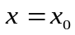. The resultant confidence interval is referred to as a "confidence interval for . The second case is where represents a prediction for the very next y that would result from setting 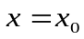. The confidence interval in the second case is referred to as a "prediction interval for ".

The formula for a confidence interval for is given by
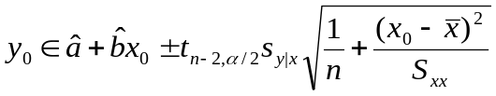
and for a prediction interval for , the formula is
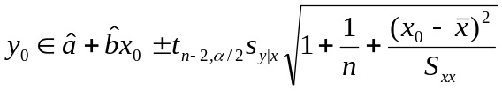.
Note the prediction interval is always wider then the corresponding confidence interval. Notice that the width of these intervals is smallest when 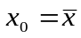. This means that in the area of our most experience, 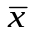, we are most confident as to the future value of 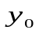. When is very far from 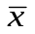, that is, when we are trying to predict a value of that is far from the area of our experience then the intervals will be very wide.

(In the above 2 formulas the value 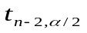 is the value of the t distribution with n-2 degrees of freedom leaving 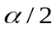 probability in the upper tail).

Example

Again, refer to our data concerning the effects of logic skills on income. Suppose that we wish to find a 95% confidence interval for the mean value of income for people who score a 6 on the logic test.

The confidence interval is then
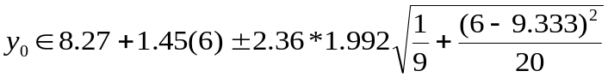
or
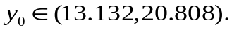

Homework

- For the data in the first regression homework set calculate a 95% confidence interval for the future mean grade for students who score an 80 on the midterm.
- For the data in the second regression homework, suppose that a certain apartment is precisely 105 meters in size. Calculate a 90% prediction interval for the coming years heating cost.

Tests of Hypotheses about the Slope b

We will now discuss three different approaches to test hypotheses about the slop b.

Consider the hypotheses
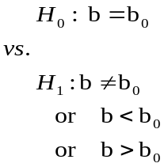
Before presenting the test of hypotheses, it should be noted that the alternative hypotheses 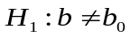 is usually the alternative most often tested. This alternative essentially tests whether the independent variable x has any effect at all on the dependent variable y. If 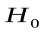is accepted, then this is interpreted as there is insufficient proof that x effects y at all. If is rejected then the data “proves” (in the statistical sense) that the value of x does effect y.

The test is to calculate the statistic
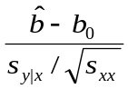
and to compare it to the appropriate tail of the t distribution. When 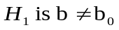 then we reject is the statistic falls either in the upper or lower tails of the t distribution with n-2 degrees of freedom of size α/2. When 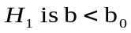 then we reject is the statistic falls in the lower tails of the t distribution with n-2 degrees of freedom of size α. When 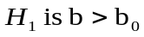 then we reject is the statistic falls in the upper tails of the t distribution with n-2 degrees of freedom of size α.

Example

Suppose we wished to test the hypotheses
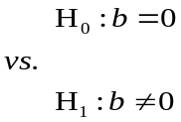
for our sample data (at a significance level α=0.05).

The appropriate test statistic is
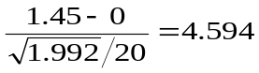
and the upper and lower α/2=0.025 tails of the t distribution with 9-2=7 degrees of freedom are 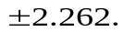
Since the test statistic (4.594) is larger then 2.262, it falls into the upper tail and we reject 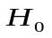. In other words, the results prove (at an 0.05 level of significance) that logic scores effect income.

Homework

- For the first regression homework data set, test the hypotheses
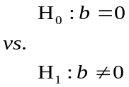
- For the second regression homework data set, test the hypotheses
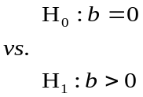

Correlation Coefficient Test

Another test of hypotheses that is completely equivalent to the test
is to test the “true” correlation coefficient ρ,
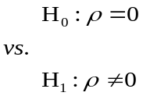
The test statistic is
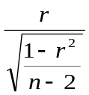
where r is the sample correlation coefficient. This statistic is distributed as a t distribution with n-2 degrees of freedom when the true value of ρ is 0. If this statistic falls into either the upper or lower tail of the t distribution of size α/2, we reject the null hypotheses otherwise we accept the null hypotheses.

This test is equivalent to the 2-sided test of b which was discussed above. However, the test for b was not restricted to being 2-sided while the test for ρ is restricted to being 2-sided.

Example

Let us test the hypotheses
for our sample data with α=0.05. We previously calculated that 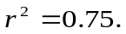 The our test statistic becomes
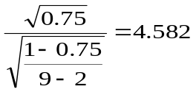
Note this is the same result we arrived at above (with a small error do to roundoff) in or test of b. As before, we compare the test statistic to the appropriate tails of the t distribution with 9-2=7 degrees of freedom (that is 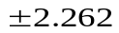). As before, we reject the null hypothesis.

Analysis of Variance Approach

A third equivalent way to test whether the slope b of the regression line is zero or not is the Analysis of Variance approach. In this approach we attempt to divide the total observed variability of the dependent variable y into two components of variability. The first is the variability that is due to true randomness, and the second is the variability in the y variable that is “explained” by the regression. The variability component do to randomness is the reason why the y values would be different even for equal x values. The variability component do to regression is the variability in the y values that is directly related to the different values of x. If the variability do to regression appears relatively large (as compared to the variability do to randomness (or error) then this would indicate a non-zero slope b for the true regression line.

We previously saw the equation
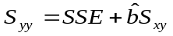.
We previously stated that this is often written as
SST=SSE+SSR
Where SST stands for the total sum of square (the total variability observed in the y’s), SSE stands for error sum of squares (or the variability do to randomness), and SSR stands for Regression sum of squares ( or the variability in the observed y’s due to the different values of x).
These values are often organized into a table called an Analysis of Variance Table.

ANOVA
Source of Variation | Sums of Squares | Degrees of Freedom | Mean Square | Computed f
Regression | SSR | 1 | MSR=SSR/1 | MSR/MSE
Error | SSE | n-2 | MSE=SSE/(n-2)
Total | SST | n-1

The computed value of f is then compared with the upper α size tail of the f distribution with 1 degree of freedom in the numerator and n-2 degrees of freedom in the denominator. If the computed f falls into this upper tail then we reject the null hypothesis that b=0 otherwise we accept the null hypothesis.

Example

For our ongoing example, we have

ANOVA
Source of Variation | Sums of Squares | Degrees of Freedom | Mean Square | Computed f
Regression | 42.05 | 1 | 42.05 | 21.10
Error | 13.95 | 7 | 1.9928
Total | 56 | 8

If we wish to do this test at an α=0.05 level of significance, then the upper 5% tail of the f distribution with 1 and 7 degrees of freedom is 5.59. Since 21.1 is greater the 5.59 we would reject the hypothesis that b=0 in favor of the hypothesis that 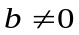.

Note that this test is completely equivalent to the previous two tests since the computed f is exactly the square of the previous test statistics and the table f value is exactly the square of the table t value of size α/2 (that is, ). (This relationship between the t and f tables is only true when the numerator degree of freedom for the f is 1).

These three tests of hypotheses are equivalent for testing
However, the first test can be expanded to a one-sided alternative hypothesis. The Analysis of Variance approach can be expanded to the more complicated situation of multiple regression (that is, regression where there is more then one x variable to “explain” the y variable). The Analysis of Variance approach can be understood as testing whether the entire set of independent variables really affects the dependent y variable.

Homework

1. For the first regression homework data set, use the Analysis of Variance approach to test the hypotheses (α=0.05)

2. For the second regression homework data set, use the Analysis of Variance approach to test the hypotheses (α=0.05)

Multiple Regression

In Simple Linear Regression we examined the model . That is , the model allows for one independent variable x to effect the values of the dependent variable y. This model is now being expanded to allow for multiple dependent variables that affect the single dependent variable y. This the model becomes
and such that the i-th observation is a (k+1)-tuple
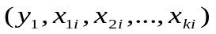.

The first objective is to estimate the unknown coefficients
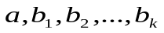.

Now the i-th error term can be written as
and the error sum of squares based on n observations is then
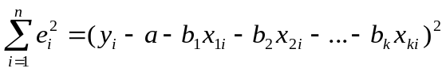.
This error sum of squares can be minimized by taking its derivative individually with respect to each of the 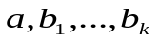. If we then set each of these derivatives equal to zero we will have (k+1) linear equations in (k+1) unknowns. These can be solved simultaneously to produce the estimates 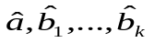 that will minimize the error sum of squares.

It is clear that this is exactly what we did in our development of Simple Linear Regression except the in the case of Multiple Regression we have far more calculations to do. Most of the ideas of Simple Linear Regression carry over to Multiple Regression as well just with far more calculations. Therefore in this class we will study Multiple Regression with the aid of a computer. We will use the facilities of Excel to carry out our calculations. We will now use a sample problem for the rest of our discussion of Multiple Regression.

Suppose we are interested in finding out what are the factors that effect the cost of eating an apartment for the winter. We can imagine that there are a number of factors that can affect the heating bill. Let’s make a list:
- The apartment size (square meters).
- Number of rooms.
- Total amount of window space.
- Floor.
- Being below the roof (expressed as 1 or 0)
- Average winter temperature.
- Average age of the couple living in the apartment.

These are the variables 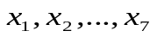 and we wish to estimate 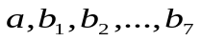. Each data point will be an 8-tuple of numbers consisting of the cost of a specific apartment and the value of these 7 variables for that apartment. Consider the following data as typed into an Excel worksheet:

cost | apartment size | rooms | window space | floor | roof | average temp | average age
2218 | 107 | 4 | 12 | 4 | 0 | 14 | 34
2492 | 74 | 3 | 12 | 5 | 1 | 16 | 32
2546 | 106 | 4 | 16 | 2 | 0 | 13 | 51
3494 | 112 | 5 | 20 | 4 | 1 | 12 | 42
2794 | 145 | 6 | 24 | 4 | 0 | 17 | 41
1921 | 70 | 3 | 9 | 2 | 0 | 10 | 21
3360 | 134 | 5 | 20 | 4 | 0 | 9 | 54
2472 | 147 | 6 | 18 | 2 | 0 | 17 | 27
1626 | 76 | 3 | 9 | 2 | 0 | 19 | 52
2293 | 78 | 3 | 9 | 3 | 1 | 19 | 51
2344 | 65 | 3 | 12 | 6 | 1 | 15 | 28
2652 | 110 | 4 | 16 | 0 | 0 | 9 | 32
1988 | 51 | 2 | 6 | 5 | 0 | 12 | 70
1815 | 56 | 2 | 6 | 0 | 0 | 12 | 66
3469 | 147 | 6 | 18 | 4 | 1 | 17 | 50
3975 | 134 | 6 | 24 | 3 | 1 | 9 | 37
2272 | 96 | 4 | 12 | 4 | 0 | 9 | 14
2008 | 92 | 4 | 12 | 1 | 0 | 15 | 44
1720 | 67 | 3 | 9 | 2 | 0 | 14 | 35
1941 | 73 | 3 | 12 | 4 | 0 | 13 | 40
1972 | 51 | 2 | 6 | 3 | 1 | 15 | 19
2573 | 109 | 4 | 12 | 4 | 1 | 17 | 28
2418 | 77 | 3 | 9 | 3 | 0 | 10 | 58
3117 | 139 | 5 | 20 | 2 | 0 | 12 | 45
2049 | 122 | 5 | 15 | 2 | 0 | 18 | 19
2648 | 115 | 4 | 12 | 3 | 1 | 19 | 40
3037 | 127 | 5 | 20 | 4 | 0 | 14 | 77
3212 | 119 | 5 | 15 | 4 | 1 | 17 | 59
2180 | 89 | 4 | 12 | 2 | 0 | 14 | 55
2788 | 90 | 4 | 12 | 3 | 1 | 15 | 55

In order to analyze this data click on TOOLS, DATA ANALYSIS, REGRESSION.

For “Input Y Range” point to cells a1 to a31.
For “Input X Range” point to cells b1 to h31.
Check the box called labels.
Choose a place on the worksheet for the output to appear.

The output will appear as follows:

SUMMARY OUTPUT
Regression Statistics
Multiple R | 0.996553
R Square | 0.993118
Adjusted R Square | 0.990929
Standard Error | 55.98242
Observations | 30
ANOVA
 | df | SS | MS | F | Significance F
Regression | 7 | 9950215 | 1421459 | 453.5562 | 2.81E-22
Residual | 22 | 68948.69 | 3134.031
Total | 29 | 10019163
 | Coefficients | Standard Error | t Stat | P-value | Lower 95% | Upper 95% | Lower 95.0% | Upper 95.0%
Intercept | 1428.644 | 67.40561 | 21.19474 | 3.95E-16 | 1288.853 | 1568.435 | 1288.853 | 1568.435
apartment size | 10.79632 | 1.400847 | 7.706994 | 1.09E-07 | 7.891136 | 13.7015 | 7.891136 | 13.7015
rooms | -7.93 | 38.73635 | -0.20472 | 0.839675 | -88.2644 | 72.40436 | -88.2644 | 72.40436
window space | 30.71289 | 6.011234 | 5.109248 | 4.05E-05 | 18.24634 | 43.17944 | 18.24634 | 43.17944
floor | 18.72132 | 8.529819 | 2.194809 | 0.039025 | 1.031542 | 36.4111 | 1.031542 | 36.4111
roof | 700.9564 | 25.67875 | 27.29714 | 1.84E-18 | 647.7019 | 754.2109 | 647.7019 | 754.2109
average temp | -77.165 | 4.049402 | -19.0559 | 3.65E-15 | -85.563 | -68.7671 | -85.563 | -68.7671
average age | 9.34385 | 0.676609 | 13.80982 | 2.56E-12 | 7.940647 | 10.74705 | 7.940647 | 10.74705

In the above Excel output first note the column labeled “Coefficients”. This column are the values . These are the “least square” estimators of . In real life the true values of can never be known. However, in this case were I generated this fictitious data from a formula, I do know what the formula is. The formula that generated this data was
Y=1500+10*apartment_size+2*rooms+30*window_space+20*floor+700*roof – 75*average_temp+8*average_age+e ,

and where e was a normal random variable with mean zero and standard deviation of 50.

Notice that the estimated coefficients are all reasonably close to the “true” values . Looking back at our output we see the value called “Standard Error” equal to 55.98242. This is the estimated value of the standard deviation of e. As previously mentioned the “true” value is 50.

Next to the “Coefficients” column there are 2 columns titled “t stat” and “P value”. These columns give the values of the t statistics that test the hypothesis
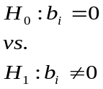
and gives the smallest α for which we would reject the hypothesis. For example, in our data the t test statistic for whether apartment size affects the yearly heating bill is 7.706994 with a P-value of 1.09E-7. This means that we would reject the null hypothesis that apartment size has no effect on heating bill for any α greater then 1.09E-7. However, for the variable “rooms” the t test statistic is -0.20472 and the associated P-value is 0.839675. Thus for α=0.05 we would accept the null hypothesis that “rooms” have no effect on the heating bill (please remember that the data is fictitious).

Turning our attention now to the portion of the output titled ANOVA. This is the very same analysis that we carried out in our discussion of Simple Linear Regression. The hypothesis that is being tested here is whether the entire set of independent variables does not affect the dependent variable y (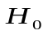), versus the hypothesis that the independent variables have an affect on y (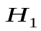). We will reject the null hypothesis if the computed f value is too large. In our case the computed f was 453.5562. This has to be compared the upper α tail of the f-distribution with 7 and 22 degrees of freedom (as reported under “df” in the ANOVA output). In the column labeled “Significance F”, Excel reports to us that we would end up rejecting the null hypothesis for any α greater than 2.81E-22. Additionally, the values reported in the column labeled “SS” are the values of SSR, SSE and SST.

In the individual t test analysis that we discussed above, we tested

for each individual variable. That is, whether each individual variable show any explanatory effect on the dependent variable. From information on the ANOVA portion of the output we can test a more complex hypothesis. Whether, any dependent variable or any group of dependent variables has an explanatory effect above and beyond the remaining variables. That is, whether there is an additional effect beyond the effects of the remaining variables. Another way of saying this whether the dependent variable or group of dependent variables has any effect after adjusting for the effects of the remaining variables.

For example, consider the variable “floor”. This variable appears to be statistically significant at α=0.05. However, perhaps the effect of floor is already captured by the other variables (specifically the variable “roof”). In order to test this we would rerun the regression with all the variables except those that we wish to test, that is, expect for “floor”. The results are then:

SUMMARY OUTPUT
Regression Statistics
Multiple R | 0.995797
R Square | 0.991611
Adjusted R Square | 0.989423
Standard Error | 60.44973
Observations | 30
ANOVA
 | df | SS | MS | F | Significance F
Regression | 6 | 9935118 | 1655853 | 453.1407 | 1.1E-22
Residual | 23 | 84045.9 | 3654.17
Total | 29 | 10019163
 | Coefficients | Standard Error | t Stat | P-value | Lower 95% | Upper 95% | Lower 95.0% | Upper 95.0%
Intercept | 1468.926 | 70.03455 | 20.9743 | 1.71E-16 | 1324.048 | 1613.803 | 1324.048 | 1613.803
apartment size | 10.38828 | 1.499252 | 6.928974 | 4.6E-07 | 7.286843 | 13.48971 | 7.286843 | 13.48971
rooms | -9.15063 | 41.82314 | -0.21879 | 0.828741 | -95.6683 | 77.367 | -95.6683 | 77.367
window space | 33.75941 | 6.315503 | 5.345482 | 1.99E-05 | 20.69482 | 46.82401 | 20.69482 | 46.82401
roof | 721.9406 | 25.73431 | 28.05363 | 2.72E-19 | 668.7052 | 775.176 | 668.7052 | 775.176
average temp | -76.3974 | 4.3562 | -17.5376 | 8.3E-15 | -85.4089 | -67.3859 | -85.4089 | -67.3859
average age | 9.387755 | 0.730282 | 12.85497 | 5.53E-12 | 7.877053 | 10.89846 | 7.877053 | 10.89846

Notice that the value of has hardly changed (it must go down a little) at all between the two outputs. This means that the predictive value of the independent variables is really not much different whether we include the variable “floor” or not. That is, “floor” doesn’t add much more information as to why the costs of heating are what they are above the information provided by the other variables. The value of SST is the same for all models since it only depends on Y. It is the values of SSE and SSR that have changed slightly. The test statistic is  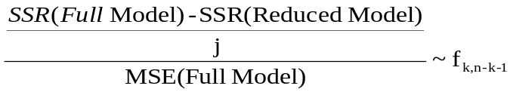  where n is the sample size and k is the number of independent variables in the full model and j is the difference in the number of independent variable between the full model and the reduced model. WE will reject (that the tested variables have no effect beyond the remaining variables) if this statistic fall into the upper tail of the f distribution (with k and n-k-1 degrees of freedom) of size α. | 55.98242

In our Case the test statistic is
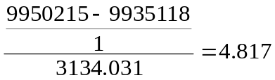
and the upper α=0.05 tail of the f distribution with 1 and 22 degrees of freedom is 4.3. We see that our statistic falls into the critical tail and our conclusion is to reject . That is “floor” does have a predictive value above the predictive value of the rest of the independent variables.

Homework
I have posted on the reshet 2 data sets.
- The first data set can be used to regress a students final average grade with a number of different predictive variables. Carry out the regression on Excel. Decide whether a students psychometric score effects his final grade average. Decide whether psychometric score and bagrut average have any additional effect above the other independent variables.
- The second data set can be used to regress monthly salary with a number of different predictive variables. Carry out the regression on Excel. Decide whether years-of-education affects a persons salary. Decide whether the general category of “education” has an additional effect on a person’s salary above the other independent variables.

Appendix 1

Distribution of 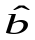 for Simple Linear Regression

Now 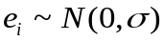 and since 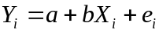 then 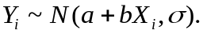
Now
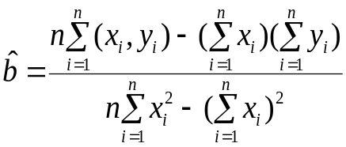
If we divide both the numerator and the denominator by n and collect terms, we get
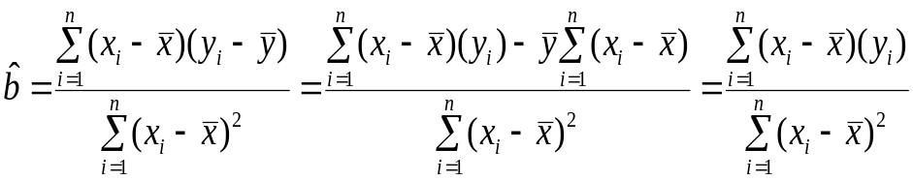
This is because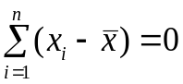 .
Now remembering that E(aX)=aE(X) and that 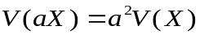, we have
- Since is a linear combination of the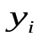which are normal the is normal.
- 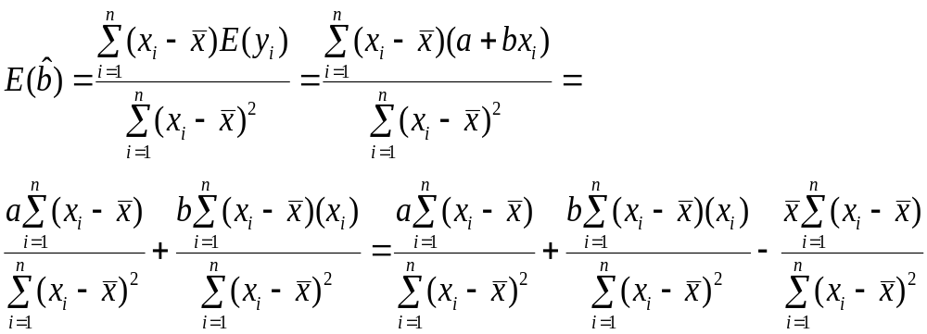we can add the last term since . For the same reason the first term also =0. Then , 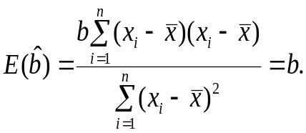
- Similarly,
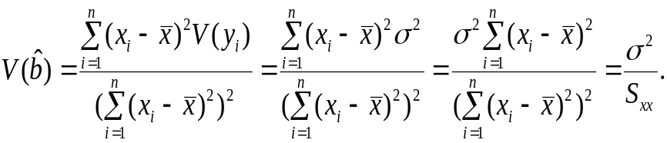

Appendix 2
A non-biased estimator for 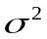

We will show that
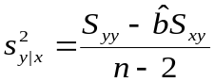 is an unbiased estimator of .
Let us rewrite the numerator as
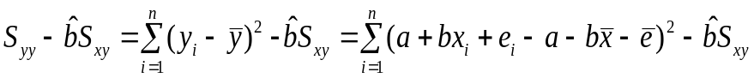
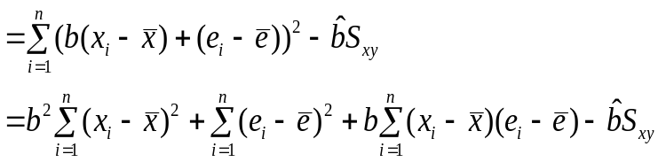

Since 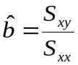 then the last expression can be written as

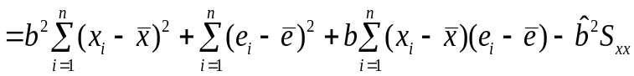
Now taking expectations, we get

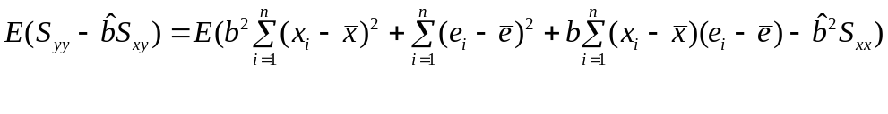Let us consider each of the 4 terms in the right hand side expectation.
a. 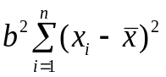is a constant and thus is its own expectation =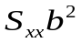 ,
b. 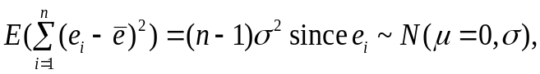
c. 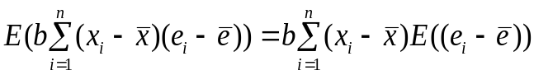
but 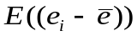are all the same and therefore,
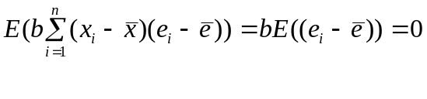
Since 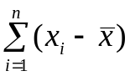=0,
d. Remembering that 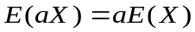 and that 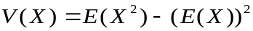, we have
Remembering that 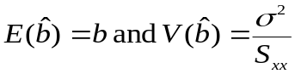 we get
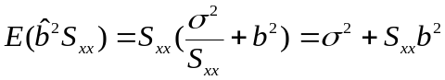

Now putting all these results (a,b,c,d) together, we have
Then
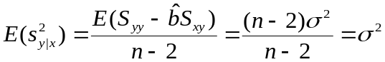
This proves that 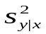 is an unbiased estimate of .

